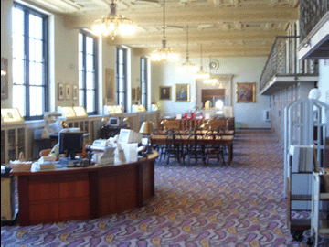by Tim Harding

In previous articles in this series, I wrote about some libraries that have fine collections of chess literature. Kibitzer 126 dealt with the second largest chess collection in public hands, the Van der Linde-Niemeijer collection at the Royal Dutch Library in The Hague, which I have been fortunate to visit on two occasions. Previous to that, I wrote about the chess collections in the British Library (February 2005) and the Harold Murray collection in the Bodleian Library, Oxford (February 2006). Only recently, however, have I had the opportunity of visiting the world?s largest chess library, the John G. White Collection at the Cleveland Public Library in Cleveland, Ohio, I spent a week there from 16-20 April.

About the White Collection  
The John G. White Collection of Chess, Checkers, Folklore and Orientalia is almost certainly the largest collection in the world of chess literature and manuscripts. Of course, there are also a few large private collections, notably that of German grandmaster Lothar Schmid, but the White collection is accessible to anyone who can visit Cleveland and it contains numerous rare and unique items, as well as an up-to-date collection of modern chess literature. This was possible because wealthy Cleveland lawyer John Griswold White (1845-1928) spent most of his lifetime building his collection and always planned to leave what he accumulated to the city library, of which he was one of the trustees. As one of the city fathers, he was involved in planning the layout of the central downtown area, in which the main library building (opened in 1923) has a beautiful setting overlooking the main plaza (known as the Mall) with a view towards Lake Erie.  
The room housing the John G. White collection, on the third floor, is particularly impressive and is high enough to have an excellent view. As the collection title indicates, White collected not only chess literature and chess artefacts but also everything he could to do with the game of checkers (draughts and its variants) and also orientalia and folklore, which he became interested in because of the oriental origins of chess. Part of the reading room for the John G. White collection  
Not only did he bequeath his collection, and arrange a superb setting for it; he also left a trust fund that enables the library to keep the collection up to date. So it is an important fact about this collection, as with the other three that I mentioned, that they not only have old materials given or bequeathed to them but also up-to-date books and periodicals also.